**NRE 538 Take Home Final**

Katie Pritchard

1. Chi Square Test of Independence

* Assumptions
  + Independence of observations 🡪 assumed ok
  + No structural zeros (every single cell within your chi square table should have prob > 0) 🡪 ok…no zeroes in my chi square table
  + Not appropriate when >20% of cells have data <5 🡪 ok…don’t have this issue
* Hypotheses
  + Ho: There is no association between gender and whether people think it’s rude to bring an unruly child on the plane.
  + Ha: There is an association between gender and whether people think it’s rude to bring an unruly child on the plane.
* Results

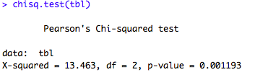

* + Since our p value < 0.05 (p=0.001193), we reject the null hypothesis that there is no association between gender and whether people think it’s rude to bring an unruly child on the plane.

1. Welch’s Two Sample T-Test



* Assumptions
  + Continuous data 🡪 ok…tuition is a continuous variable
  + Data is normally distributed or sample size is > 30 🡪 ok. Although the p value from the Shapiro-Wilk test of our data is <0.05 (p=3.193e-15) would lead us to reject the null hypothesis that the data is normally distributed, we can assume normality since our sample size is well over 30 and can be assumed to follow the central limit theorem (nprivate = 872, npublic = 535).

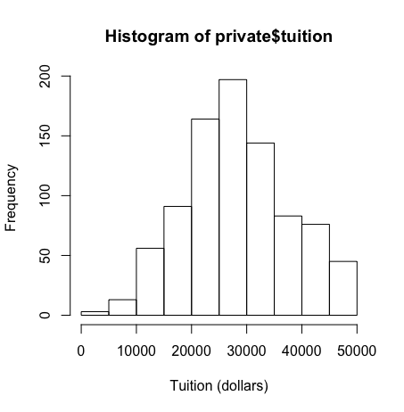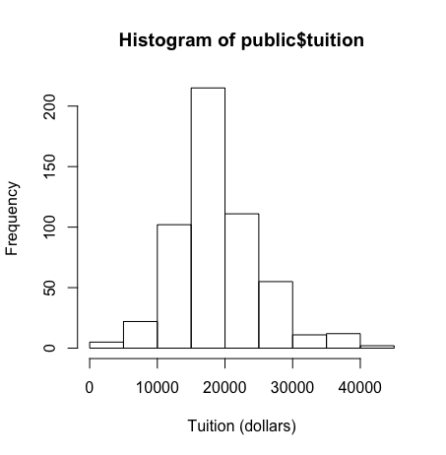

* + Samples have equal variance 🡪 failed. I ran a var.test and since p<0.05 (p<2.2e-16), we reject the null hypothesis that the true ratio of variances is equal to one and conclude that the populations do not have equal variance.
  + Each observation is sampled independently 🡪 assumed ok
  + Sample is randomly selected 🡪 assumed ok
* Hypotheses
  + Ho: There is no significant difference in mean tuition price between private nonprofit colleges and public colleges.
  + Ha: There is a significant difference in mean tuition price between private nonprofit colleges and public colleges.
* Results
  + Since we violated the assumption of equal variances, I ran a Welch Two Sample t-test. Since our p value was less than 0.05, we reject the null hypothesis and conclude that there is a significant difference in the mean tuition price at private nonprofit colleges and public colleges.

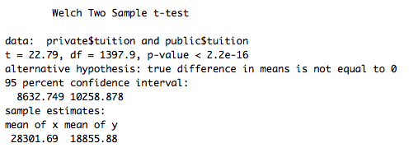

1. One-way ANOVA



* Assumptions
  + Populations are normally distributed 🡪 ok. Although I ran a Shapiro-Wilk test for the data and since our p value was only 0.012 (meaning we’d reject the null hypothesis that the data follows a normal distribution), we have well over 30 observations and can assume normality.
  + Samples are independent of one another 🡪 assumed ok.
  + Each population has the same variance 🡪 ok. I ran a Levene test and since p>0.05 (p=0.5179), we fail to reject the null hypothesis that each population has the same variance.
* Hypotheses
  + Ho: There is no difference in happiness scores between regions.
  + Ha: There is a difference in happiness scores between regions.
* Results
  + Since p<0.05, we reject the null hypothesis and conclude that there is a significant difference in happiness scores between regions.

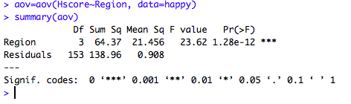

1. Multiple Linear Regression

* Choosing my continuous IVs
  + To see what variables might be most important in predicting Corruption, I ran the full linear model (Corruption~Generosity+Freedom+Life+Hrank+Hscore+Family). Based on the p values for each independent variable, only the p values for Freedom, Hscore, and Family were significant so I assumed that these would be three important variables to include in trying to predict Corruption.

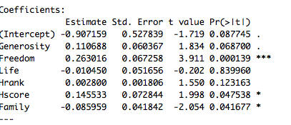

To see if I would face any issues with multicollinearity with these three variables, I calculated correlation coefficients and found that Hscore was strongly correlated with both Family and Freedom (r=0.74 and r=0.57, respectively) and Family and Freedom were moderately correlated (r=0.45). To see if this meant that my variables were too correlated, I checked variance inflation factors. None of my VIFs were greater than 5 so I decided to proceed with using the three variables in my model, since it didn’t appear as though collinearity would introduce significant bias.

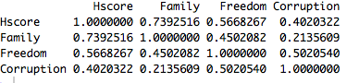

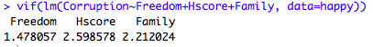

* Model checking
  + I plotted the dependent variable (Corruption) to see if it was normally distributed and it had a positive right skew and a Shapiro Test p value <0.05 (p=5.128e-11). The qqplot for Corruption~ Freedom+Family+Hscore also indicated non-normality of the residuals. As such, I tried a few different transformations of the dependent variable to see if I could get my residuals to be normally distributed.

 

* + Log transformation: A log transformation of Corruption made the Y variable more normal (p value for the Shapiro test increased to 0.08). My residuals passed the dwtest and bptest, indicating independence and homoscedasticity, but my residuals were not normally distributed, as evidenced by the 0.005 p value from my Shapiro test. While the qqplot looked better, it still didn’t look like the log transformation of Corruption had solved normality issues with the residuals.

 

* + Cube root transformation: My cube root transformed Y variable didn’t pass Shapiro, but was fairly close (p = 0.02) and much higher than the p value for the un-transformed Y variable. After putting the cube root transformed Y variable in my linear model, my data passed the dwtest (indicating independence of residuals), bptest (indicating homoscedasticity), and Shapiro test (indicating normally distributed residuals). The qqplot also looked much better.

 

* + Square root transformation: My transformed Y variable did not pass Shapiro (p=0.0001). When re-running the linear model, my residuals passed the dwtest (p=0.08), the bptest (0.1576), and the Shapiro test (0.3983). The qqplot also looked pretty good.

 

* + I decided to proceed with the cube root transformed DV. This transformation elicited the best looking qqplot and the data met all of the assumptions needed to run a linear model.
* Assumptions
  + Normality of errors 🡪 ok. The Shapiro test p value for our residuals was 0.7528 and the qqplot looked pretty good. Both indicate that the residuals are normally distributed.
  + Homoscedasticity of errors 🡪 ok. I ran a bptest and my p value was 0.5098, which means that I do have equal variance of the residuals.
  + Independence of errors 🡪 ok. I ran a Durbin-Watson test and my p value was 0.1281, which means I failed to reject the null hypothesis that true autocorrelation is 0. Therefore, I have independence of errors.
  + Linear relationship between predictor and response variables – ok. I calculated the correlation coefficient between cube root(Corruption) and the predictor variables and there seemed to be moderately strong linear relationships between cube_Y and Freedom (r=0.48) and cube_Y and Hscore (r=0.35). The linear relationship between Family and cube_Y was weak but not 0 (r=0.16), so I decided to proceed anyways with running the multiple linear regression.

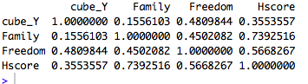

* Results

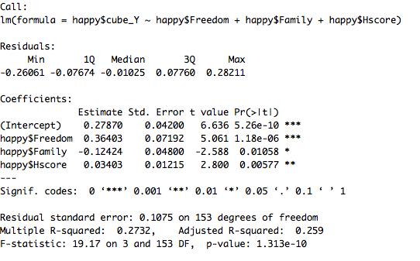

* + The coefficient of the intercept tells us that when all of our predictor variables are set at 0, the cube root of Corruption is 0.2787 and since the p value is <0.05, this is significantly different than 0. Back transforming this (0.27873), we can say that Corruption is 0.022 when all of the predictor variables are 0. The estimate for Freedom tells us that for every unit increase in Freedom, the cube root of Corruption increases by 0.36 (or, when back transforming 0.36, Corruption increases by 0.047 units. Freedom has a significant effect, since the p value is <0.05. The estimate for Family tells us that for every unit increase in Family, the cube root of Corruption decreases by 0.124 units (or, when back transforming, Corruption decreases by 0.002 units. This is significant, since p<0.05. Finally, for every unit increase in Hscore, the cube root of Corruption increases by 0.034 and this is significant.
  + Overall, this model explains 25.9% of the variability in Corruption, as evidenced by the adjusted R2. Further, our F test p value tells us that the probability for the null model to explain the same amount of variance as our model is very low (p=1.313e-10).

1. ANCOVA

* Assumptions 🡪 ANCOVAs have the same assumptions as linear regressions so please see above for assumption checking. I proceeded using the cube root-transformed DV in this ANCOVA.

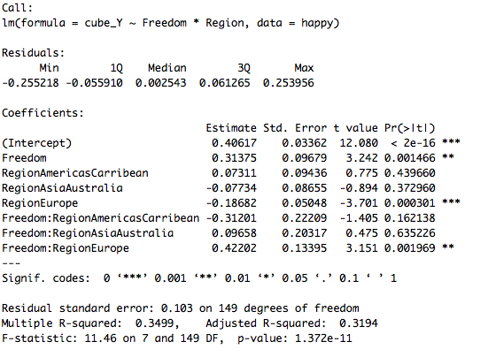

* Results
  + When Freedom is 0, the estimated cube root of corruption in AfricaMideast (alphabetically the first region) is 0.40617 (or, if you back transform this, it’s 0.067). For every unit increase in freedom in AfricaMideast, the cube root of corruption increases by 0.31375 units, which is significant. When back transforming this, we can say that for every unit increase in freedom in AfricaMideast, corruption increases by 0.031 units. We also see that when controlling for freedom, changing the region from AfricaMideast to Europe results in a unit decrease of -0.18682 in cube root(Corruption). The p-value for this is <0.05, which means that switching from AfricaMideast to Europe elicits a significant decrease in corruption (when controlling for Freedom). Our interaction term for Freedom:RegionEurope is also significant, which means the relationship between Freedom and Corruption is significantly different in Africa:Mideast than Europe. This means that the coefficient of Freedom differs significantly whether you’re in Europe or Africa:Mideast. In total, this model explains 31.94% of the variability in Corruption, as shown by the adjusted R2 value.

1. GLM w/ binomial

* Choosing independent variables
  + To choose which independent variables to include in my model, I calculated the correlation coefficients. Whether or not a tumor was malignant appeared to be highly correlated with radius_mean, perimeter_mean, and area_mean and only moderately correlated with smoothness_mean and texture_mean. However, since perimeter, area, and radius are all measurements that are related to each other, I wanted to only include one of those variables in my model. So I chose area_mean, as well as smoothness_mean and texture_mean.

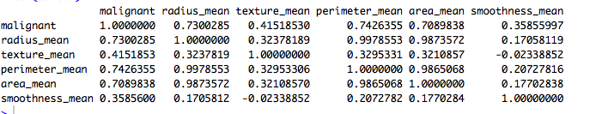

* Assumptions
  + Observations are independent 🡪 assumed ok
  + DV is from a broader exponential family 🡪 ok…Since our dependent variable is binary (tumor is either malignant or not malignant), it’s from a binomial distribution.
  + Linear relationship between transformed DV and independent variables 🡪 ok
* Results

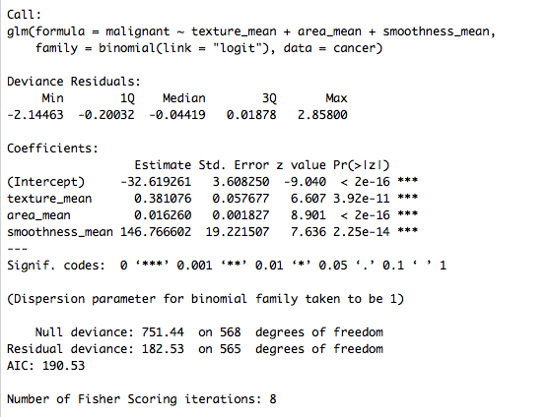

* + The probability for a tumor to be malignant after transformation is significantly influenced by the mean texture.
  + For every increase in mean radius, the log odds of malignancy decreases by 0.385. This means that for every 1 unit increase in mean radius, the odds of your tumor being malignant decreases by a factor of 0.68 (exp(-0.385) = 0.68). However, this is not significant. For every increase in mean texture, the log odds of malignancy increases by 0.209. So for every 1 unit increase in mean texture, the odds of your tumor being malignant increases by a factor of 1.23 and, since p<0.05, this is significant. For every increase in mean area, the log odds of malignancy increases by 0.016. This means that for every 1 unit increase in mean area, the odds of your tumor being malignant increase by a factor of 1.02 but this is not significant.

1. To see which of the independent variables I included in my model in the prior question were most important in explaining whether a breast cancer tumor is malignant or not, I compared models using ANOVA and AIC. I built a series of nested models, with the null model (mod0) being malignant~1. In mod1 I added in radius_mean as the IV, in mod2 I added in texture_mean, and then in mod3 I added area_mean as the last IV.

I first compared the AIC scores for each model. Moving from mod0 to mod3, the AIC score decreased with the addition of each independent variable, although the decrease was very small moving from mod2 to mod3. In looking at this, it would appear that since the AIC for mod1 is less than mod0 and since mod2 is less than mod0 and mod1, including the independent variables of radius_mean and texture_mean could increase the likelihood of our model. Again, the AIC for mod3 was lower than mods0-2 but only slightly so I wanted to run an ANOVA to see how significant the increase in likelihood would be by adding in the last independent variable (area_mean).

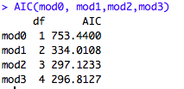

In running an ANOVA and looking at my summary table, I had significant p values (<0.05) when adding radius_mean to the null model and then from adding texture_mean, which is what I expected in looking at their models’ AIC scores. However, the addition of area_mean did not result in a significant p value. As such, I determined that including both radius_mean and texture_mean as independent variables could increase the likelihood of the model and that this increase was significant. In this case, the full model was not a significant improvement on the null model and mod2 (which included radius_mean and texture_mean) significantly increased the likelihood of the model. Therefore, they were the most important factors in explaining whether or not a breast cancer tumor would be malignant.

